Title Tag: Gene Therapy | Pfizer
Priority Keywords: gene therapy, genetics in medicine, rnai, rna inference

Gene Therapy Website Manuscript
Approved: XX.XX.XX

Overview: The following manuscript outlines new Gene Therapy pages to be created on Pfizer.com.
Landing Page: Gene Therapy

PAGE DETAILS
URL: www.pfizer.com/science/innovation/gene-therapy
Page Title: UNLOCKING THE PROMISE OF GENE THERAPY
Description: Page will introduce gene therapy site and highlight the areas of focus for page
Title Tag: Gene Therapy | Pfizer
Meta Descrip: Gene therapy has the potential to offer eligible patients with rare genetic diseases a transformational clinical benefit and improve quality of life. Our expertise and commitment to gene therapy research, along with our strategic investments, have given us end-to-end capabilities that facilitate the discovery and development of gene therapies and enable high-quality, scalable manufacturing, with the aim to deliver these next-generation therapies to patients upon approval.

PAGE COPY
Page Title: UNLOCKING THE PROMISE OF GENE THERAPY

Home / Science / Areas of Innovation / Gene Therapy

Format: Featured Component: Two-column wrapper with Tile Text and Links
Tile text:
- H4: Find out more about how our pioneering work is unlocking the promise of gene therapy for patients with rare genetic diseases.
Links:
- Gene as a Medicine: https://www.pfizer.com/science/innovation/gene-therapy/genes-as-medicines
- Gene Therapy’s Promise: https://www.pfizer.com/science/innovation/gene-therapy/gene-therapy-promise
- Gene Therapy Manufacturing: https://www.pfizer.com/science/innovation/gene-therapy/manufacturing

Format: Featured Component: BrightCove Single Video
Eyebrow: Interactive Look at Gene Therapy Manufacturing
Body: H4: Gene therapy development is a complex task, requiring specialized and novel methodologies, as well as a high level of expertise. Tour our state-of-the-art gene therapy-focused manufacturing complex in Sanford, North Carolina and explore how gene therapies are made.

Video title: Intro
Short Description: Pfizer is working to unlock the promise of gene therapy for patients worldwide living with rare genetic diseases for whom the current standard of care falls short.

(Note: above image provided as a sample of video functionality only; manufacturing video is in development and will be shared upon RC approval)

Format: Featured Component: Tile Text with Links
Eyebrow: Clinial Trials
Body: H4: Learn more about the process of joining a clinical trial and find a trial near you.
Link: Go to Pfizer Clinical Trials Site: https://www.pfizerclinicaltrials.com/

Format: Featured Component: Use Existing Pipeline view/block from https://www.pfizer.com/science/drug-product-pipeline
Title: Pipeline Snapshot as of February 8. 2022
Link: Download Complete Pipeline PDF

Tab 1: Gene Therapy: Genes as Medicine

PAGE DETAILS
URL: www.pfizer.com/science/innovation/gene-therapy/genes-as-medicines
Page Title: GENE THERAPY: GENES AS MEDICINE
Description: Page describes gene therapy and discusses the different approaches (in vivo / ex vivo Gene Therapy, Gene Editing, and RNAi)
Title Tag: Gene Therapy: Genes As Medicine | Pfizer
Meta Descrip: Using genetics in medicine. Gene therapy uses genes as medicine targeting the underlying cause of genetic diseases and the different gene therapy approaches.

PAGE COPY
Copy: Gene therapy is the next generation of medicine targeting the underlying cause of a genetic disease. It has the potential to offer patients a transformational clinical benefit and dramatically improve quality of life.

Format: Featured Component: BrightCove Single Video
Video title: Cure Hunters: Gene Therapy
Caption: Delve into the science behind Pfizer’s innovative approach.

Format: Expandable Content
Header: GENETICS: KEY TERMS
What is a Gene? +
A gene is the basic physical and functional unit of heredity, and is made up of DNA. The Human Genome Project estimated that humans have between 20,000 and 25,000 genes. Though small, our genes are a blueprint for how each cell in the body functions, made up of 30 million codes of DNA.

What is a Genetic Disease? +
A genetic disease is caused by an alteration in an individual’s DNA, oftentimes inherited or, in rare cases, occurring spontaneously. Genes play an essential role in determining the function of each cell in the body, made up of 30 million codes of DNA. If even one of these codes is damaged, a gene alteration may occur causing a genetic disease, some of which can be debilitating and life-threatening.

What is Gene Therapy? +
Gene therapy is a new generation of medicine where a functioning gene is delivered to a targeted tissue in the body to produce a missing or nonfunctioning protein. By using genes as medicine, the underlying cause of a disease can be targeted at the cellular level, potentially with just one treatment.

What is in vivo gene therapy? What is ex vivo Gene Therapy? +
For in vivo, the functioning gene is transferred to the cell inside the body via an infusion and is used as a blueprint to produce the missing or nonfunctioning protein. For ex vivo, patient’s cells are removed and exposed to the desired gene outside of the body, then re-infused to add the functioning gene back in the body.

What is Gene Editing? +
Gene editing is a precise change of a patient’s DNA using site-specific, targeted nucleases (eg, CRISPR, Zinc Finger). This approach either permanently removes or modifies a gene, or adds a functioning gene within the patient’s body.

Are There Other Genetic Approaches? +
Another approach uses RNAi technology to change the expression of a gene by targeting product of DNA transcription (RNA). This approach more or less “silences” the dysfunctional gene attributed to the genetic disease.

Format: Tile Text with Image Embedded and Clickable

Header: GENE THERAPY: BREAKTHROUGHS THAT CHANGE PATIENTS’ LIVES
Please click image below to download full Fact Sheet.

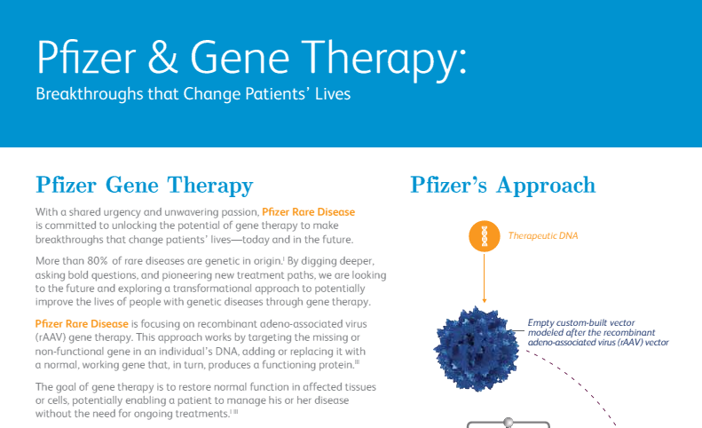
FPO

Format: Expandable Content
Header: GENE THERAPY: FREQUENTLY ASKED QUESTIONS
Please click here to download full FAQ.

What are the potential benefits of gene therapy? +
Unlike traditional medications, which often require frequent administration and focus on managing symptoms and disease progression, gene therapy aims to address the non-functioning gene and provide a long-term treatment benefit with potentially just one dose.

However, while gene therapy holds promise for people with genetic diseases, it will not be an appropriate solution for every patient. The potential risks and benefits of gene therapy will emerge with continued research and evaluation.

What are the potential challenges of gene therapy? +
Some patients may have been exposed to AAV and may have developed antibodies to this virus and therefore would not be a candidate for treatment. These patients may develop an immune response immediately post treatment, where the body neutralizes the therapeutic gene’s function. If caught early, clinical experience shows these responses may be able to be treated with steroids, potentially leading to a stabilization of the gene’s functioning.

How do you know if you may be eligible for gene therapy? +
Eligibility for gene therapy treatments will be determined by a number of criteria, including a blood test to check for antibodies to the custom vector. Patients can discuss the test criteria and results with their physicians and determine how to proceed on an individual basis. Factors that may make someone ineligible to receive gene therapy treatment include patients with preexisting antibodies that would neutralize the specific gene therapy treatment, patients who have previously received gene therapy and developed these antibodies, and for certain diseases, the age of the patient at the time of treatment.

How long does gene therapy last? +
Clinical trials are currently underway to explore the many unknowns, including how long a particular gene therapy may last. That said, evidence to date indicates gene therapy has the potential to increase or restore function in affected tissues or cells over a long period of time and may enable a patient to manage his or her disease without the need for ongoing treatments.

Format: Related Articles (Carousel)
      - Article 1
  - Title: Turning the Promise of Gene Therapy into Reality
  - Link: https://www.pfizer.com/news/articles/turning_the_promise_of_gene_therapy_into_a_reality
  - Copy: Pfizer's Rare Disease team is focusing on highly specialized, potential gene therapy treatments, and clinical trials are underway to explore the potential of gene therapy. By targeting the underlying cause of a genetic disease, Pfizer hopes to restore normal function in affected…
      - Article 2
  - Title: What is Gene Therapy
  - Link: https://www.pfizer.com/science/innovation/gene-therapy
  - Copy: Gene therapy is a technology aimed at correcting or fixing a gene that may be defective. This exciting and potentially transformative area of research is focused on the development of potential treatments for monogenic diseases, or diseases that are caused by a defect in one gene…
      - Article 3
  - Title: What Is Duchenne Muscular Dystrophy?
  - Link: https://www.pfizer.com/focus-areas/rare-disease/duchenne-muscular-dystrophy
  - Copy: Muscular dystrophies are a debilitating group of illnesses that not only rob children of their ability to move properly, but can dramatically shorten their lives.

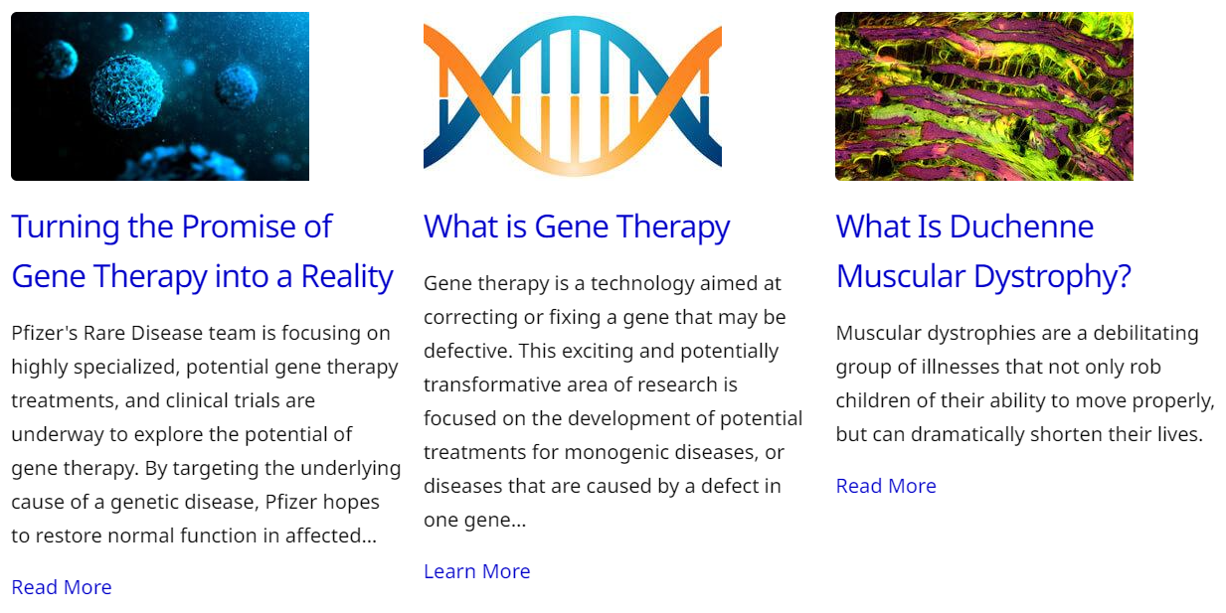

Tab 2: Gene Therapy’s Promise: Future Uses, Applications & Prospects

PAGE DETAILS
URL: www.pfizer.com /science/innovation/gene-therapy/gene-therapy-promise
Page Title: GENE THERAPY’S PROMISE: FUTURE USES, APPLICATIONS & PROSPECTS
Description: The potential of genes as medicine and the impact gene therapy may have on patients and caregivers
Title Tag: Gene Therapy’s Promise: Future Uses, Applications & Prospects | Pfizer
Meta Descrip: The potential of genes as medicine and the impact gene therapy may have on patients and caregivers. Creating treatment options for rare genetic diseases.

PAGE COPY

Copy: About 320 million people worldwide live with a rare genetic disease.¹ By unlocking the promise of gene therapy for millions worldwide, Pfizer is pioneering breakthroughs that will change patients’ lives.
Gene therapy could enable patients to live without the need for ongoing treatments or the burden of daily disease management.² We’re going beyond helping people manage their diseases. We want them to thrive in every stage of life.
Format: Tile Text with Image Embedded and Clickable
Caption: Please click the image below to download the Gene Therapy Fact Sheet:
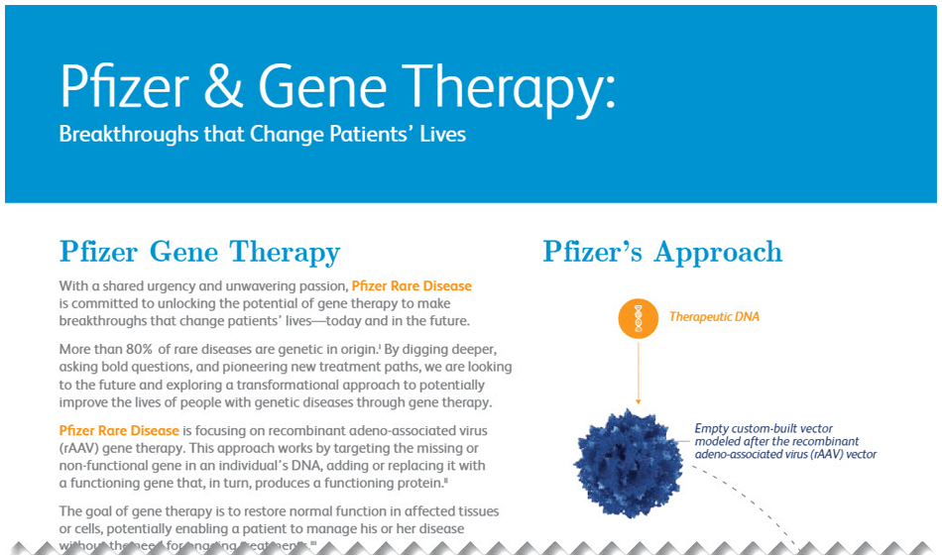
FPO
FPO
Format: Image Gallery (THIS IS THE OLD FORMAT, REFER HERE FOR NEW FORMAT)
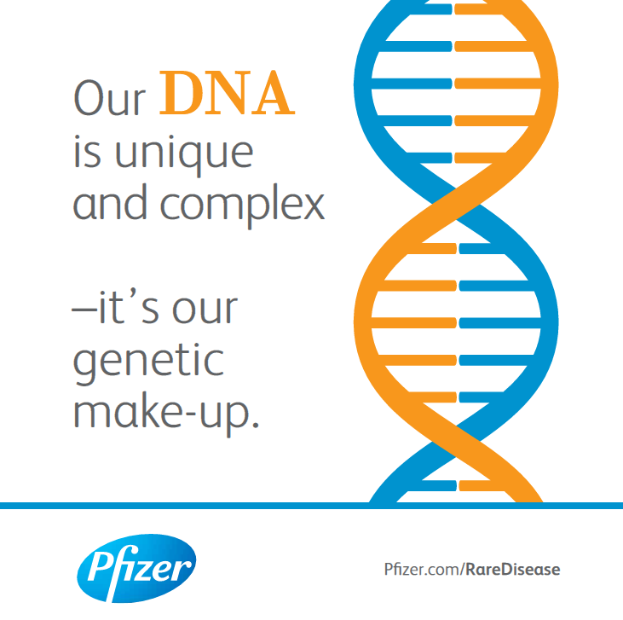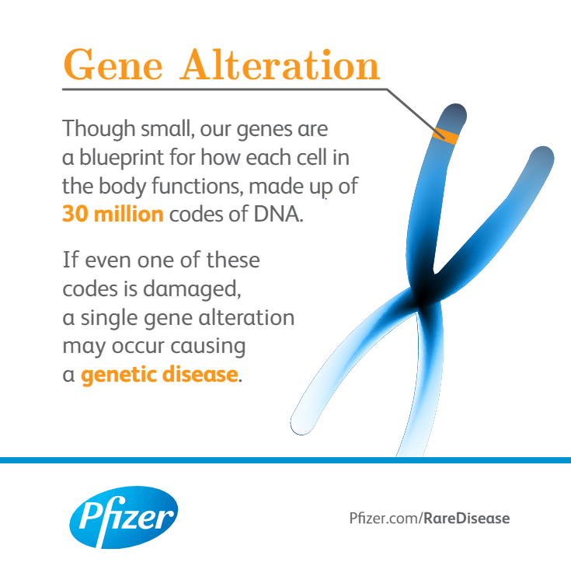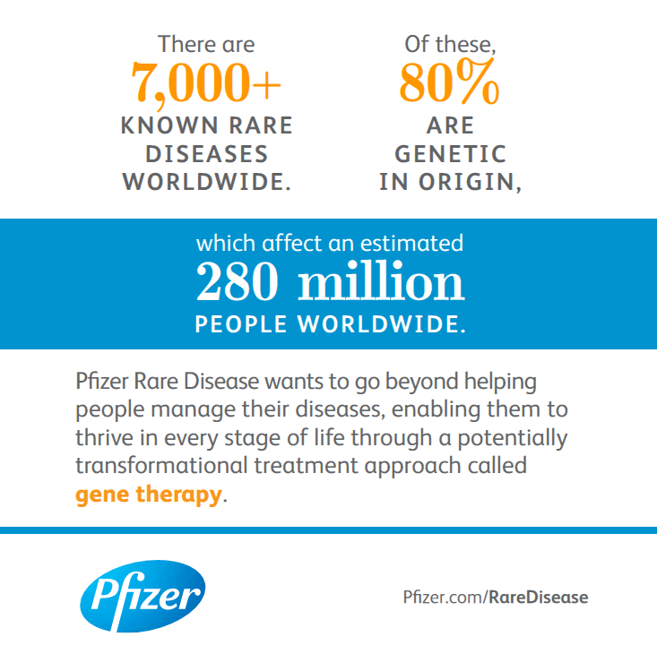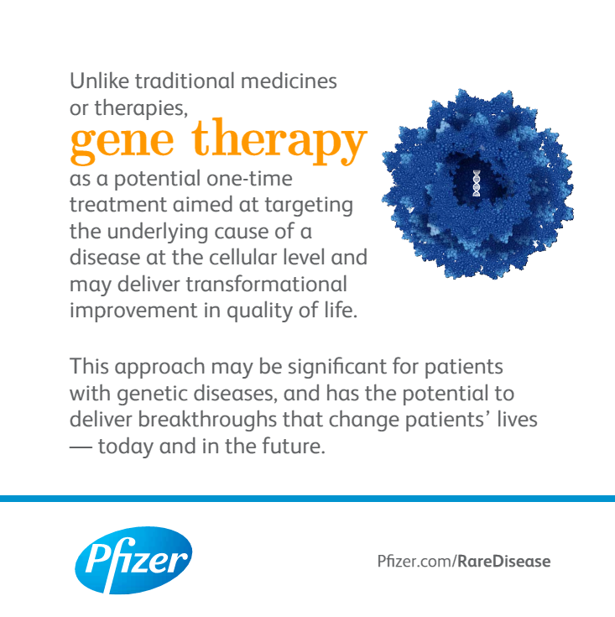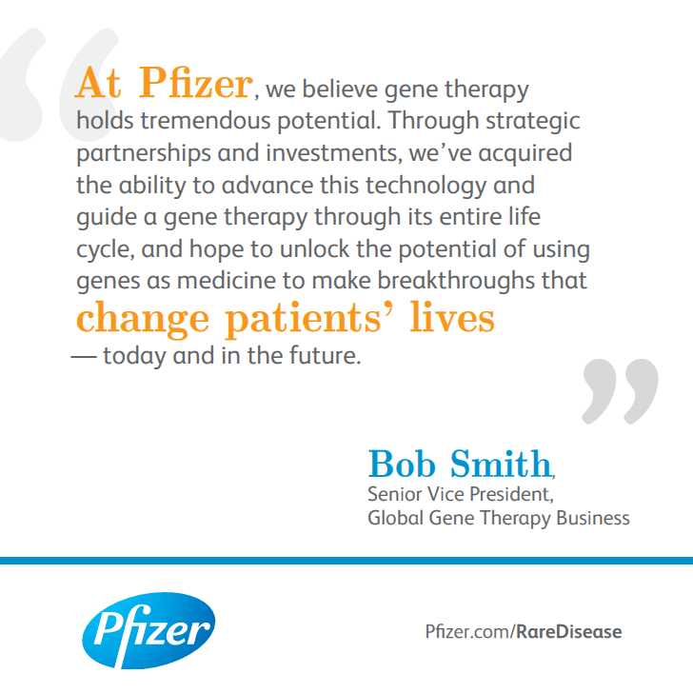
FPO
FPO
FPO
FPO

Format: Expandable Content

Header: GENE THERAPY: FREQUENTLY ASKED QUESTIONS
Download the Gene Therapy FAQ

What is a Genetic Disease? +
A genetic disease is caused by an alteration in an individual’s DNA, oftentimes inherited or, in rare cases, occurring spontaneously. Genes play an essential role in determining the function of each cell in the body, made up of 30 million codes of DNA. If even one of these codes is damaged, a gene alteration may occur causing a genetic disease, some of which can be debilitating and life-threatening.

What is Gene Therapy? +
Gene therapy is a new generation of medicine where a functioning gene is delivered to a targeted tissue in the body to produce a missing or nonfunctioning protein. By using genes as medicine, the underlying cause of a disease can be targeted at the cellular level, potentially with just one treatment.

How do you know if you may be eligible for gene therapy? +
Eligibility for gene therapy treatments will be determined by a number of criteria, including a blood test to check for antibodies to the custom vector. Patients can discuss the test criteria and results with their physicians and determine how to proceed on an individual basis. Factors that may make someone ineligible to receive gene therapy treatment include patients with preexisting antibodies that would neutralize the specific gene therapy treatment, patients who have previously received gene therapy and developed these antibodies, and for certain diseases, the age of the patient at the time of treatment.

How long does gene therapy last? +
Clinical trials are currently underway to explore the many unknowns, including how long a particular gene therapy may last. That said, evidence to date indicates gene therapy has the potential to increase or restore function in affected tissues or cells over a long period of time and may enable a patient to manage his or her disease without the need for ongoing treatments.

Format: Related Articles (Carousel)
- Article 1
  - Title: Turning the Promise of Gene Therapy into a Reality
  - Link: https://www.pfizer.com/news/articles/turning_the_promise_of_gene_therapy_into_a_reality
  - Copy: Pfizer's Rare Disease team is focusing on highly specialized, potential gene therapy treatments, and clinical trials are underway to explore the potential of gene therapy. By targeting the underlying cause of a genetic disease, Pfizer hopes to restore normal function in affected tissues or cells...
- Article 2
  - Title: The A’s and B’s of Hemophilia
  - Link: https://www.pfizer.com/news/featured_stories/featured_stories_detail/the_a_s_and_b_s_of_hemophilia
  - Copy: Hope on the Horizon for an Inherited Clotting Disorder When we sustain a cut or injury, more than a dozen clotting factors, or special proteins circulating in the body, are activated in a cascade to help us stop bleeding. &...
- Article 3
  - Title: Pioneering a New Era of Care: Gene Therapy
  - Link: https://www.pfizer.com/news/featured_stories/featured_stories_detail/pioneering_a_new_era_of_care_gene_therapy
  - Copy: Pfizer Rare Disease is working to target the underlying causes of certain genetic diseases by focusing on highly specialized, potentially one-time gene therapy treatments. Genes play an essential role in determining the function of each cell in the body, making up 30 million codes of DNA. If even...
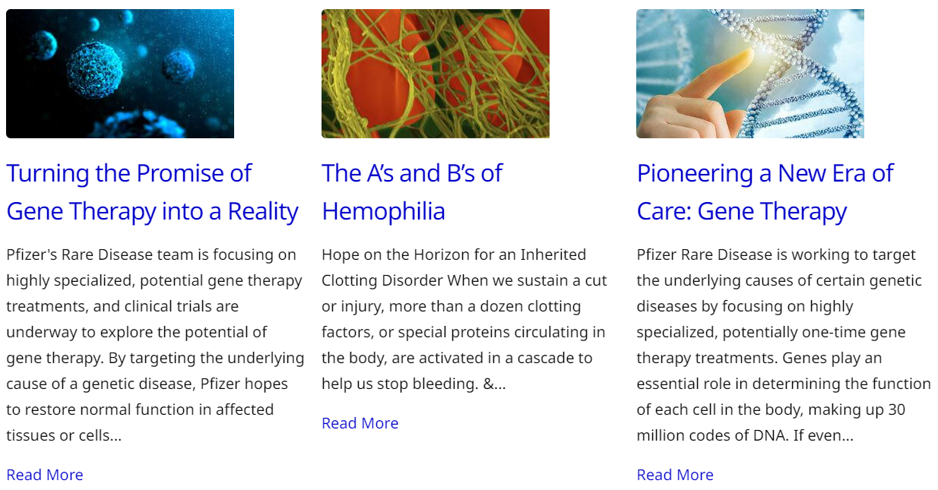
Tab 3: Gene Therapy Videos

PAGE DETAILS
URL: www.pfizer.com/science/innovation/gene-therapy/manufacturing
Page Title: GENE THERAPY VIDEOS
Description: Behind-the-scenes look into Pfizer’s gene therapy manufacturing capabilities
Title Tag: Gene Therapy Videos | Pfizer
Meta Descrip: Gene therapy manufacturing. Gene therapy development creates highly specialized treatments that use custom-made recombinant adeno-associated virus (AAV).

PAGE COPY

Title: GENE THERAPY VIDEOS

Format: Featured Component: Two-column wrapper with Tile text and Image/Video block

Tile Text Header or Eyebrow: Introduction

Copy: Pfizer is working to unlock the promise of gene therapy for patients worldwide living with rare genetic diseases for whom the current standard of care falls short. Over the past several years, we’ve made investments in innovative gene therapy technology and facilities giving us end-to-end capabilities and enabling us to guide a gene therapy medicine through its entire life cycle.

Image/Video block: BrightCove Single Video
Video title: Intro
Caption: Pfizer is working to unlock the promise of gene therapy for patients worldwide living with rare genetic diseases for whom the current standard of care falls short.

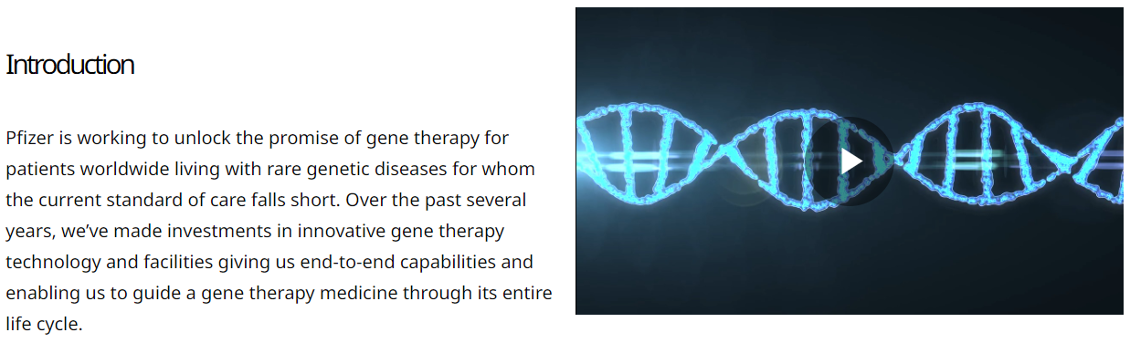
(Note: above image provided as a sample of video functionality only; manufacturing video is in development and will be shared upon RC approval)

Format: Featured Component: Tile text with embedded BrightCove Video Galleries

Header: How Pfizer Manufactures Gene Therapies
Copy: The gene therapy manufacturing process is very specific, delicate and intentional. Pfizer follows four main steps to produce each dose of a gene therapy: preparing raw materials, encapsulating the desired gene during the upstream process, purifying the viral vector during the downstream process and then packaging the treatment for clinical or commercial use.

Insert: BrightCove Video Gallery 1 (Link to video assets and title/descriptions for each here).

Header: Unique Elements of the Gene Therapy Manufacturing Process
Copy: There are a few more steps of the manufacturing processes that are specific to gene therapies, compared to other types of medicines, vaccines and treatments. This includes a process called transfection, the use of specific kidney cells called HEK cells and single-use technologies to accelerate production.

Insert: BrightCove Video Gallery 2 (Link to video assets and title/descriptions for each here).

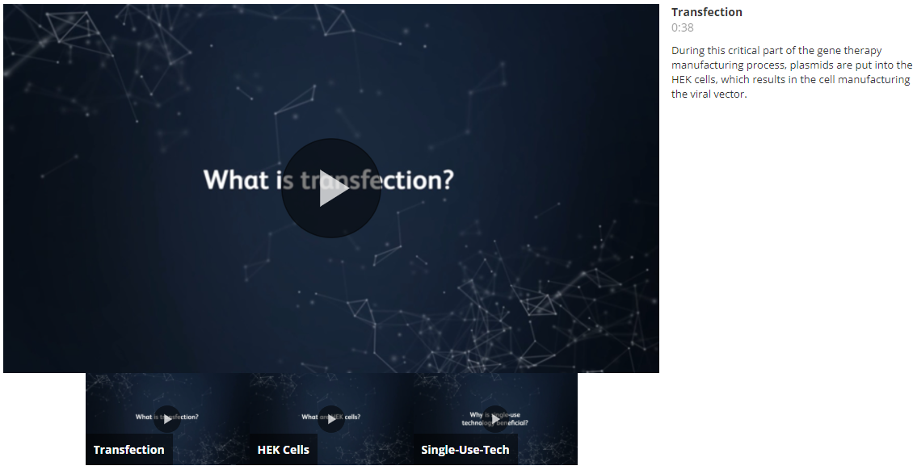

Header: The Drivers of our Manufacturing Capabilities
Copy: Our motivated team of scientists, paired with our advanced manufacturing facilities, are essential to Pfizer’s ability to manufacture gene therapies. These components enable us to deliver on the promise of gene therapy for patients living with rare genetic diseases.

Insert: BrightCove Video Gallery 3 (Link to video assets and title/descriptions for each here).

###

